**Noisy signal Generation**

Combination of signal and noise may be modelled in following two ways

1. Addition of noise to the signal of interest
2. Multiplication of the signal of interest and the noise signal.

**Addition of noise and signal:**-

Additive noise is the simplest kind of noise. The noise signal simply gets added to the signal of interest. Mathematically we may write

X(t) = s(t) + n(t)

n(t) = noise

s(t) = original signal,

x(t) = final signal.

Additive noise is the simplest kind of noise and is easiest to remove. In the experiment a simple sine wave was taken as the signal of interest and white noise was added to the signal. The time domain plot of the white noise is as shown

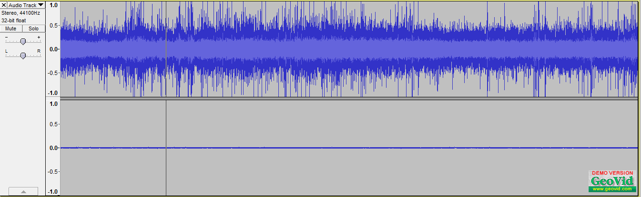

**Time Domain plot of the noise**

The corresponding frequency domain plot is as shown in following figure

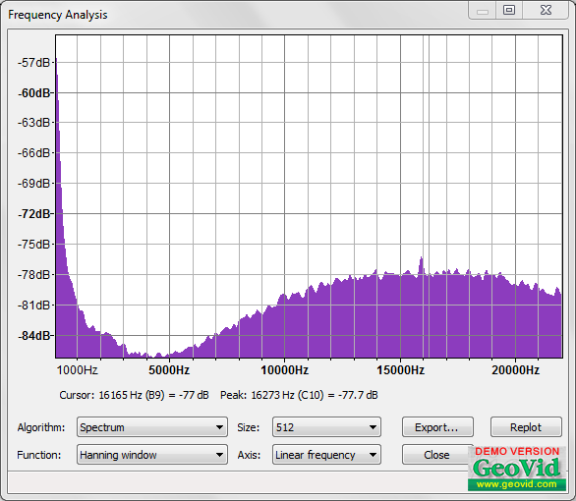

**Frequency domain plot**

The sum of sinusoidal and the noise gives the following plot in the time domain.

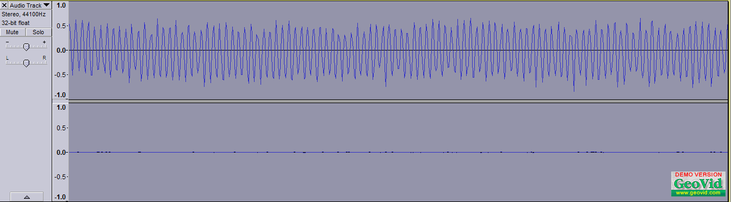

**Time Domain addition of noise and signal**

The Addition can be clearly seen in the frequency domain. Addition in the time domain simply adds the signals in the frequency domain. The frequency domain plot is as follows.

In the time domain there is a random variation in the amplitude of the signal the addition is clear from the frequency domain plot there is a constant background white noise. Corresponding to the sine wave there is a peak at the frequency of the sine wave. The two plots shown in the figure show addition of white noise and sine waves of different frequencies in the frequency domain.

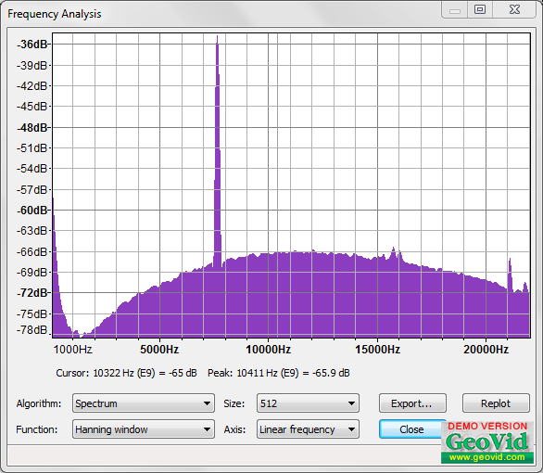

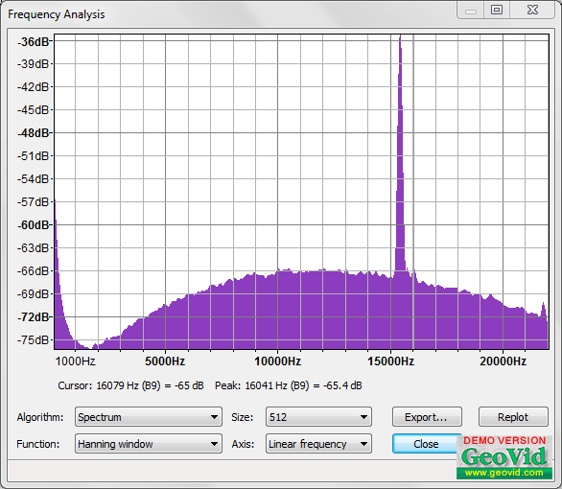

**Frequency domain plot of signal and noise for 2 different frequencies**

In addition to adding a single tone frequency to the noise we may also add a base band signal with a limited bandwidth to the noise. A baseband signal may be generated by passing a triangular wave through an lpf. A triangular wave has infinite harmonics, however on passing through an lpf creates a baseband signal with limited number of harmonics. The time domain triangular signal passed through an lpf is shown in the figure below. The frequency domain representation of the signal is shown in the latter figure.

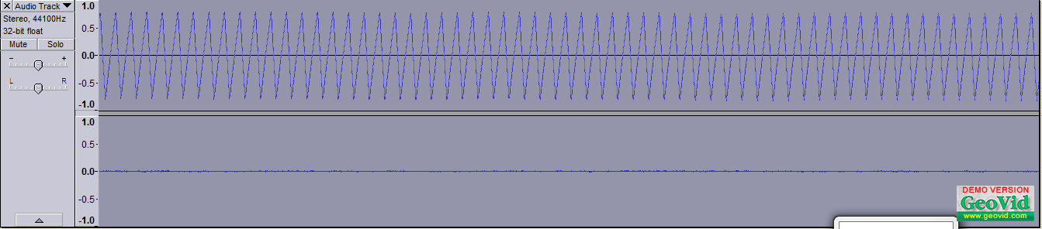

**Time domain signal**